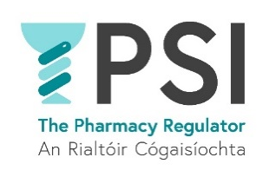

Application Form

Name:

Position applied for:

E-mail address:

Telephone number:

Practical details
How many years of professional experience in pharmacy, healthcare or quality-related role do you have? | Choose an item.
Do you hold minimum third level 8 degree in pharmacy, healthcare or quality related discipline? | Yes ☐ No ☐
Please provide details:

Do you have access to your own vehicle, and are able and authorised to drive? | Yes ☐ No ☐
Do you have experience of good practice in pharmacy or quality systems in healthcare or other areas? | Yes ☐ No ☐
Please provide details:

Do you have experience in any of the following:  - Within a regulatory body or function.  - In inspection and compliance or quality processes.  - Working with standards to improve quality of health or other services.  - In the healthcare sector.  - In quality assessment/assurance roles. | Yes ☐ No ☐  Yes ☐ No ☐  Yes ☐ No ☐  Yes ☐ No ☐  Yes ☐ No ☐
Please provide details:

Do you hold a postgraduate qualification in a relevant area such as healthcare management, quality and/or risk management | Yes ☐ No ☐
Please provide details:

Do you require sponsorship, now or in the future, to work in Ireland? | Yes ☐ No ☐
If yes, please provide details:
Do you have any special requirement, in relation to either communications or access, should you be invited to interview? | Yes ☐ No ☐
If yes, please provide details:
Where did you see this position advertised?
Do you consent for your data to be used and stored as part of the recruitment process for this position? | Choose an item.

Thank you for your interest in the PSI – the Pharmacy Regulator.

Please send a completed Application Form, Cover Letter and C.V. to recruitment@psi.ie

