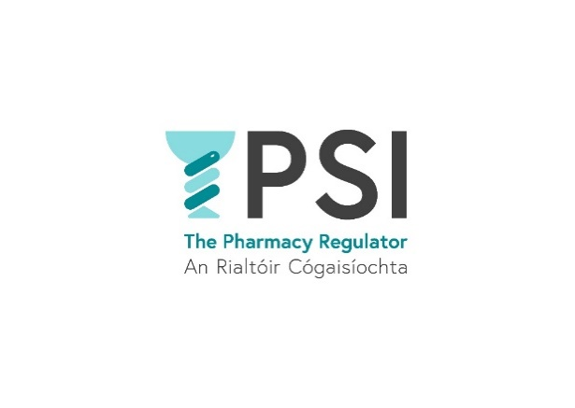

**Application Form**

**Name**:

**Position applied for**:

**E-mail address:**

**Telephone number:**

|  |  |
| --- | --- |
| **Practical details** | |
| **Are you a registered Pharmacist with the PSI or entitled to be so registered** | **Yes  No** | |
| **How many years of demonstrable leadership experience at an appropriate senior level do you have?** | Choose an item. | |
| **How would you describe your working knowledge of Microsoft packages?** | Choose an item. | |
| **Do you have substantial experience in at least one of the following areas:**   * **Healthcare professional education, training and ongoing development?** * **Comprehensive experience working in a statutory regulatory environment?** | **Yes  No** | |
| **Do you require sponsorship, now or in the future, to work in Ireland?** | **Yes  No** | |
| **If yes, please provide details:** |  | |
| **Do you have any special requirement, in relation to either communications or access, should you be invited to interview?** | **Yes  No** | |
| **If yes, please provide details:** |  | |
| **Where did you see this position advertised?** |  | |
| **Do you consent for your data to be used and stored as part of the recruitment process for this position?** | Choose an item. | |

**Thank you for your interest in the PSI – the Pharmacy Regulator.**

Please send a completed Application Form, Cover Letter and C.V. to [recruitment@psi.ie](mailto:hr@psi.ie)