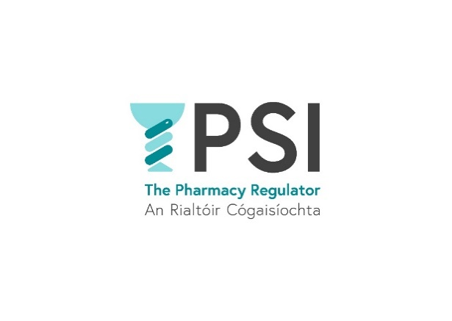

**Application Form**

**Name**:

**Position applied for**:

**E-mail address:**

**Telephone number:**

|  |  |
| --- | --- |
| **Practical details** | |
| **How many years work experience in a regulatory, healthcare or regulated setting do you have.** | Choose an item. | |
| **Please provide details:** |  | |
| **Do you hold a relevant third-level qualification (Level 7 or higher on the National Framework of Qualifications), or equivalent, in disciplines such as public administration, regulation, quality systems, public health, social policy, healthcare or social care; or a professional qualification in a health or social care discipline;?** | **Yes  No** | |
| **Please provide details:** | | |
| **Do you have access to your own vehicle, and are able and authorised to drive?** | **Yes  No** | |
| **Do you have experience** **in compliance activities, inspection or quality assurance processes.** | **Yes  No** | |
| **Do you have experience in, and/or knowledge of, working with standards to improve the quality of health or other services.** | **Yes  No** | |
| **Please provide details:** | | |
| **Do you require sponsorship, now or in the future, to work in Ireland?** | **Yes  No** | |
| **If yes, please provide details:** |  | |
| **Do you have any special requirement, in relation to either communications or access, should you be invited to interview?** | **Yes  No** | |
| **If yes, please provide details:** |  | |
| **Where did you see this position advertised?** |  | |
| **Do you consent for your data to be used and stored as part of the recruitment process for this position?** | Choose an item. | |

**Thank you for your interest in the PSI – the Pharmacy Regulator.**

Please send a completed Application Form, Cover Letter and C.V. to [recruitment@psi.ie](mailto:hr@psi.ie)