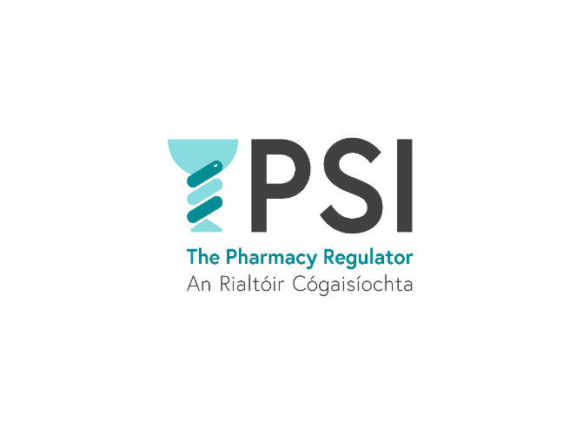

Application Form
PSI Audit and Risk Committee Member
January 2026

The PSI is seeking expressions of interest from suitably qualified persons for appointment to its Audit and Risk Committee.

- All appointments to the Committee are subject to approval by the PSI Council.

- Suitably qualified candidates who are not selected on this occasion, will be placed on a reserve panel from which future vacancies on the Committee will be filled. The panel will remain in place until January 2028.

- The PSI strives to be a diverse and inclusive workplace and adheres at all times to current employment equality legislation.

If you are interested in applying please complete and return the form to Éanna Ó Lochlainn either by email or post to;
eanna.olochlainn@psi.ie

Éanna Ó Lochlainn, Governance and Planning Officer, PSI House, 15-19 Fenian Street, Dublin 2, D02 TD72.
no later than 5pm on Friday, 13th of February 2026

The PSI will not accept applications which are not submitted on this form, or which are received after the closing date.

SECTION 1: PERSONAL DETAILS

Please fill in all fields
Title: | Surname: |  | Forename:
Address:

Phone: |  | Email:
Country of Residence:

SECTION 2: COMPETENCIES

Please reflect on the competencies set out in the information booklet and provide your responses in the sections below. Please ensure you provide sufficient detail to demonstrate your experience and knowledge. Aim to complete each field in 250 words, or less.

- Please outline your relevant experience in one, or more, of the following areas: (a) Risk Management, (b) Governance, (c) Accounting (d) Auditing as well as any experience you have of the public sector operating environment.

- Please provide an example that demonstrates your ability to work collaboratively and constructively with others as part of a diverse team.

- Committee members are required to have good interpersonal, oral and written communication skills. Please provide an example which demonstrate how you meet this requirement.

- Briefly outline any additional contributions/expertise you wish to highlight in relation to how you meet the competencies required for membership of the Audit and Risk Committee.

SECTION 3: DECLARATION

I hereby certify and declare that:

- All the information I have provided on this application is correct to the best of my knowledge and belief.
- I do not know, or am not aware, of any conflict, or potential conflict of interest, which would prevent my appointment as a member of the PSI Audit and Risk Committee.
- I am computer literate, and have sufficient information technology (IT) skills, to conduct Committee business digitally, or by electronic means, when required to do so, and if necessary, work in a paperless environment.

Name: ____________________________________________

Date: _____________________________________________

Any person found to have given false information or to have wilfully suppressed any material fact will be disqualified.

Please see the data protection notice contained in the Information Booklet for the PSI Audit and Risk Committee. The PSI will process any personal data in relation to your application in accordance with Data Protection legislation. More information is available in our Data Protection Statement.

