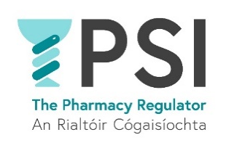

Application Form

Name:

Position applied for:

E-mail address:

Telephone number:

Practical details
A level 8 degree or equivalent on the National Framework of Qualifications (NFQ) and/or a professional | Yes ☐ No ☐
How many years hands of relevant professional experience do you have? | Choose an item.
Do you have previous experience in pension administration and/or payroll processing? | Yes ☐ No ☐
If yes, please provide details:
Do you require sponsorship, now or in the future, to work in Ireland? | Yes ☐ No ☐
If yes, please provide details:
Do you have any special requirement, in relation to either communications or access, should you be invited to interview? | Yes ☐ No ☐
If yes, please provide details:
Where did you see this position advertised?
Do you consent for your data to be used and stored as part of the recruitment process for this position? | Choose an item.

Thank you for your interest in the PSI – the Pharmacy Regulator.

Please send a completed Application Form, Cover Letter and C.V. to recruitment@psi.ie

