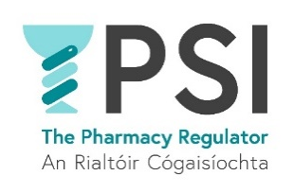

Application Form

Name:

Position applied for: Customer Relations and Registration Lead

E-mail address:

Telephone number:

Practical details
How many years of post-qualification experience do you have? | Choose an item.
Which area(s) do you have experience in?  Tick all that applies  We don’t expect candidates to have experience in all areas. Experience in a minimum of one of the areas is an essential requirement. | ☐ Customer service operations  ☐ Administration  ☐ Regulation  ☐ Team management
How would you describe your experience in implementing process improvement initiatives? | Choose an item.
Do you require sponsorship, now or in the future, to work in Ireland? | Yes ☐ No ☐
If yes, please provide details:
Do you have any special requirement, in relation to either communications or access, should you be invited to interview? | Yes ☐ No ☐
If yes, please provide details:
Where did you see this position advertised?
Do you consent for your data to be used and stored as part of the recruitment process for this position? | Choose an item.

Thank you for your interest in the PSI – the Pharmacy Regulator.

Please send a completed Application Form, Cover Letter and C.V. to recruitment@psi.ie

