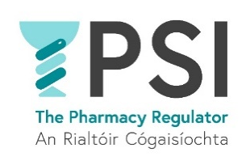

Application Form

Name:

Position applied for:

E-mail address:

Telephone number:
Practical details
Are you a qualified solicitor or barrister, admitted to either the Roll of Solicitors in the Republic of Ireland or the Roll of Practising Barristers, and hold a valid practising certificate? | Yes ☐ No ☐
How many years of relevant management experience do you have to include significant experience in people management? | Choose an item.
Please provide details:

Do you have a minimum of 10 years’ post-qualification experience, to include experience in regulatory as well as public and administrative law | Yes ☐ No ☐
Please provide details:

Do you have previous experience in instructing counsel, committees and external lawyers | Yes ☐ No ☐
Please provide details:

Do you require sponsorship, now or in the future, to work in Ireland? | Yes ☐ No ☐
If yes, please provide details:
Do you have any special requirement, in relation to either communications or access, should you be invited to interview? | Yes ☐ No ☐
If yes, please provide details:
Where did you see this position advertised?
Do you consent for your data to be used and stored as part of the recruitment process for this position? | Choose an item.

Thank you for your interest in the PSI – the Pharmacy Regulator.

Please send a completed Application Form, Cover Letter and C.V. to recruitment@psi.ie

